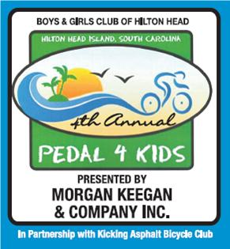

Please join us for a
Pedal 4 Kids Recognition Reception
Friday, September 24, 2010
6:30 p.m. to 8:00 p.m.
Boys and Girls Club of Hilton Head Island-Gym
Recognition to all our
Sponsors, Donors, Team Captains and Volunteers!!
Catered by Carrabba’s Italian Grill

